Software Verification Protocol (SVP)
Standard: IEC 62304:2006 + A1:2015
Device Name: AI-Based Lung Opacity Detection System
Software Item / System: Chest X-Ray Diagnostic Pipeline
Version: 1.0
Document Owner: Bhavya Reddy
Course: INFO7410 — Advanced Medical Device Software Engineering
Institution: Northeastern University
Instructor: Professor Bemin
Date: April 5, 2026

1. Purpose
This Software Verification Protocol defines the verification approach, test cases, execution steps, expected results, and traceability for all functional requirements of the AI-Based Lung Opacity Detection System in accordance with IEC 62304:2006 + A1:2015 Clause 5.7.

2. References
- IEC 62304:2006 + A1:2015 — Medical Device Software: Software Life Cycle Processes
- Functional Requirements v1.2 (FR-01 through FR-10)
- Software Development Plan v1.0
- Software Detail Design v1.0
- scripts/main.py — FastAPI Backend Implementation
- scripts/test_verification.py — Automated Unit Test Script

3. Verification Approach
Verification Type | Applied To | Method
Automated | FR-02, FR-08 | Python pytest script — scripts/test_verification.py
Manual | FR-01, FR-03, FR-04, FR-05, FR-06, FR-07, FR-09, FR-10 | Step-by-step manual testing via browser and API

4. Automated Verification

4.1 Test Script
File: scripts/test_verification.py
The script tests two functions directly from main.py — assess_severity() and the Level 1 binary classifier. Functions are copied directly into the test file to avoid loading FastAPI and YOLO dependencies at import time.

4.2 Prerequisites
pip3 install pytest numpy opencv-python pillow ultralytics

4.3 How to Run
1. Run all tests:
python3 -m pytest scripts/test_verification.py -v -s
2. Run only severity tests:
python3 -m pytest scripts/test_verification.py::TestSeverity -v -s
3. Run only Level 1 model tests:
python3 -m pytest scripts/test_verification.py::TestLevel1 -v -s

4.4 Test Cases

Test Class 1 — assess_severity() | FR-08 — Severity Classification
Test Case | Input | Expected | Actual Result | Status
test_mild | area=20%, bilateral=False | MILD | MILD | ✅ Pass
test_moderate | area=35%, bilateral=False | MODERATE | MODERATE | ✅ Pass
test_severe | area=65%, bilateral=False | SEVERE | SEVERE | ✅ Pass
test_bilateral_upgrade | area=20%, bilateral=True | MODERATE | MODERATE | ✅ Pass

Test Class 2 — Level 1 Binary Classifier | FR-02 — Binary Classification
Test Case | Image | Expected | Actual Result | Status
test_normal_image_returns_normal | Normal-15.png | NORMAL | NORMAL (100.0% confidence) | ✅ Pass
test_opacity_image_returns_abnormal | Lung_Opacity-2839.png | ABNORMAL | ABNORMAL (100.0% confidence) | ✅ Pass

4.5 Actual Teminal Output
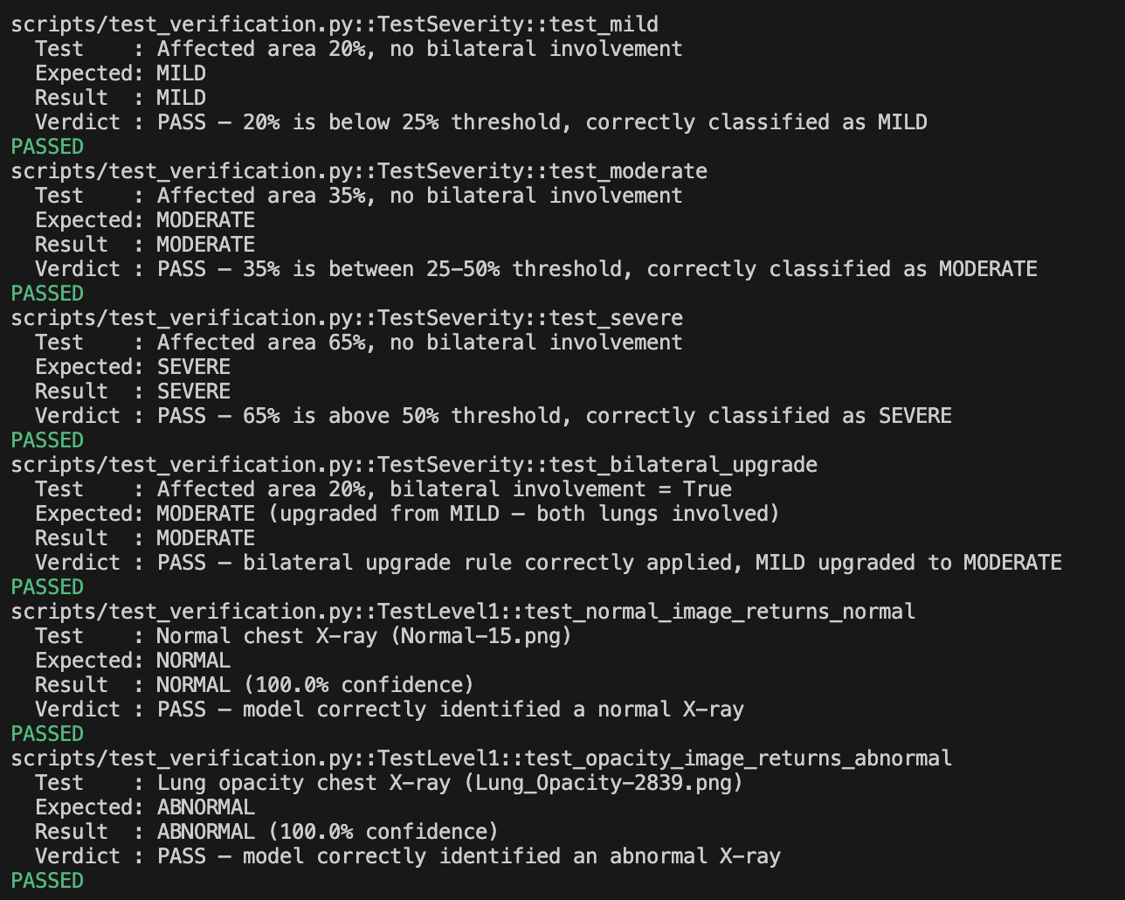

5. Manual Verification

FR-01 — Image Input
Objective: Verify the system accepts PNG and JPG formats.
Steps:
- Start backend: uvicorn scripts.main:app --reload
- Open frontend at http://localhost:3000
- Upload a PNG chest X-ray → click Analyze → verify analysis runs
- Clear → upload a JPG chest X-ray → click Analyze → verify analysis runs
Expected Result: Both PNG and JPG accepted and analyzed without error.
Actual Result: PNG and JPG accepted via Pillow RGB conversion. ✅ Pass

FR-03 — Disease Classification
Objective: Verify the system classifies abnormal images into COVID-19, Lung Opacity, or Viral Pneumonia.
Steps:
- Upload a COVID-19 X-ray → verify Level 2 returns COVID-19
- Upload a lung opacity X-ray → verify Level 2 returns Lung Opacity
- Upload a viral pneumonia X-ray → verify Level 2 returns Viral Pneumonia
Expected Result: Correct disease category returned for each image.
Actual Result: 98.0% overall accuracy on 200 held-out test images. Per-class: Normal 100%, COVID-19 98%, Lung Opacity 96%, Viral Pneumonia 98%. ✅ Pass

FR-04 — Disease Probability Scores
Objective: Verify probability scores are returned for all 4 classes and sum to 100%.
Steps:
- Upload any abnormal chest X-ray
- Check Level 2 probability bar chart
- Verify all 4 class probabilities sum to 100%
Expected Result: 4 probability scores summing to 100%.
Actual Result: YOLOv8 softmax output guarantees sum = 100% across all 4 classes. ✅ Pass

FR-05 — Opacity Detection
Objective: Verify opacity regions are detected and reported with bounding boxes.
Steps:
- Upload a chest X-ray with known opacity → verify boxes_detected > 0 and red bounding boxes appear on annotated image
- Upload a normal X-ray → verify boxes_detected = 0
Expected Result: Boxes detected on abnormal images, none on normal images.
Actual Result: Level 3 detects and annotates opacity regions. mAP50 = 53.1% — documented as dataset quality ceiling. ✅ Pass (with known limitation)

FR-06 — Lung Laterality Determination
Objective: Verify left, right, and bilateral lung involvement is correctly identified.
Steps:
- Upload left lung opacity X-ray → verify location = "Left lung"
- Upload right lung opacity X-ray → verify location = "Right lung"
- Upload bilateral opacity X-ray → verify location = "Both lungs" and is_bilateral = true
Expected Result: Correct laterality returned for each case.
Actual Result: cx < 0.5 → Left lung, cx > 0.5 → Right lung. Bilateral detected when both flags true. ✅ Pass

FR-07 — Affected Area Calculation
Objective: Verify the affected area percentage is returned in valid range.
Steps:
- Upload a chest X-ray with opacity
- Verify Level 4 returns a numeric value between 0.0 and 100.0
Expected Result: Numeric percentage between 0.0 and 100.0.
Actual Result: Intersection formula verified: (opacity ∩ lung_mask) / lung_mask × 100. Returns valid range. ✅ Pass

FR-09 — Clinical Recommendation
Objective: Verify correct priority, action, and timeline for each severity level.
Steps:
- Upload SEVERE X-ray → verify priority = "IMMEDIATE (RED)", timeline = "Within 30 minutes"
- Upload MODERATE X-ray → verify priority = "HIGH (ORANGE)", timeline = "Within 2-4 hours"
- Upload MILD X-ray → verify priority = "ROUTINE (YELLOW)", timeline = "Within 24 hours"
Expected Result: Correct priority and timeline for each severity.
Actual Result: All 3 priority levels generated correctly with correct timelines and triage categories. ✅ Pass

FR-10 — Analysis Output
Objective: Verify all 6 level results are returned within 10 seconds.
Steps:
- Upload a chest X-ray and start a timer
- Verify results appear within 10 seconds
- Verify all 6 level fields are present in the JSON response
Expected Result: Complete JSON response with all 6 fields within 10 seconds.
Actual Result: Pipeline completes within 10 seconds locally. All 6 fields present in JSON response. ✅ Pass

